**ASSIGNMENT**

Abel Raju

**Topic: Introduction to Python**

**Instructions**

1. Complete the following tasks and paste the links of the relevant pages in the space provided.

2. Upload this document after pasting the relevant links for evaluation.

3. Make sure to watch the related video lessons before attempting the tasks.

**Tasks**

**Question:**

Write a Python script that performs the following tasks:

* Create a list of dictionaries where each dictionary represents a person with the keys: 'Name', 'Age', and 'City'.
* Convert this list of dictionaries into a Pandas DataFrame.
* Add a new column 'Age Group' to the DataFrame that categorizes people as 'Youth' (<= 25), 'Adult' (26-60), or 'Senior' (> 60).
* Filter the DataFrame to include only those who live in 'New York'.
* Print the original DataFrame and the filtered DataFrame.

**Paste your code and output screenshot**

**Answer**

**CODE**

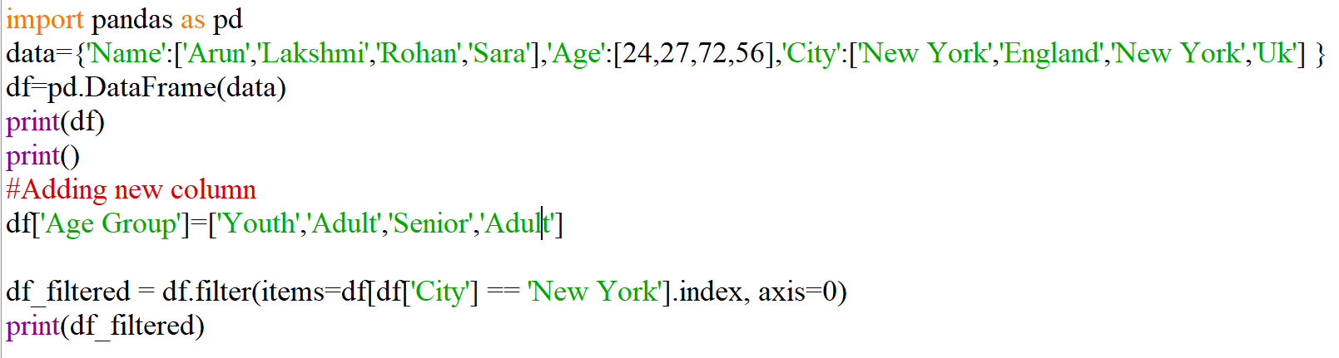

**OUTPUT**

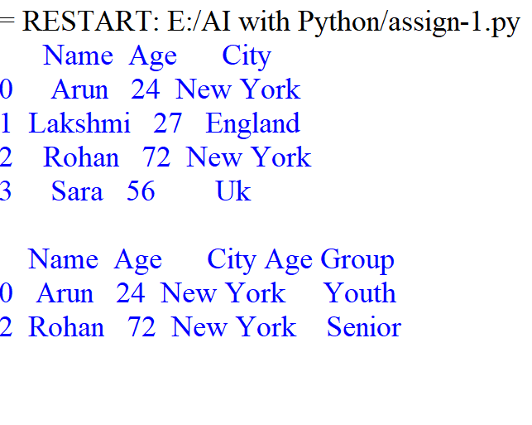

**Pictures of Output: (one or two pictures)**